**Documentation of Course Management System**  
**Author:** Eray Kalafat  
**Data:** 11/10/2024  
  
Tester in a Course Management System plays a critical role in ensuring the system's reliability, functionality, and user experience. This involves evaluating software components and workflows designed for managing courses, students, instructors, and related academic activities.

**History of technical documentation**

**Author**

| Fac No: | Name | E-mail |
| --- | --- | --- |
| 273222033 | Eray Kalafat | [eraykalafat6@gmail.com](mailto:eraykalafat6@gmail.com)  ekalafat@tu-sofia.bg |

Version history

| Version | Data | Author | Description |
| --- | --- | --- | --- |
| 1.0 | 10/11/2024 | Eray Kalafat | Together with the Project Manager, the team developed the main idea and purpose of the project.I'm a testing developer based on the created structure. |
| 1.1 | 15/11/2024 | Eray Kalafat | A meeting was held with the Project Manager, and a draft of the project was created. |
| 1.2 | 25/11/2024 | Eray Kalafat | Using the data received from the Front-end Developer, student and teacher login trial tests were conducted." |
| 1.3 | 29/11/2024 | Eray Kalafat | A meeting was held with the Back-end Developer and the Project Manager to examine database issues. |
| 1.4 | 02/12/2024 | Eray Kalafat | Issues were reviewed and resolved together with the Front-end Developer. The fixes were verified during testing. |
| 1.5 | 10/12/2024 | Eray Kalafat | Issues were reviewed and resolved together with the Back-end Developer. The fixes were verified during testing. |

**Content**

**Introduction**

According to the project distribution, discussions were held with both the front-end and back-end developers, and collaboration took place to work on specific errors and resolve them. The data was collected and the errors were communicated.

The tester verifies key features like login functionality, course management, grade tracking, and user interface behavior by performing test cases. This helps identify any bugs, issues, or inconsistencies before the system is deployed for actual use. The goal is to ensure that both students and teachers can access their respective dashboards and perform tasks efficiently and securely.

**Testing  
  
Login;**Login Form for Student:

Username: The student’s username is "273222039".

Password: The student’s password is "123456"  
  
When the student enters the correct username and password and submits the form, the login will be successful, and the student will be redirected to the student’s course dashboard.  
  
  
  
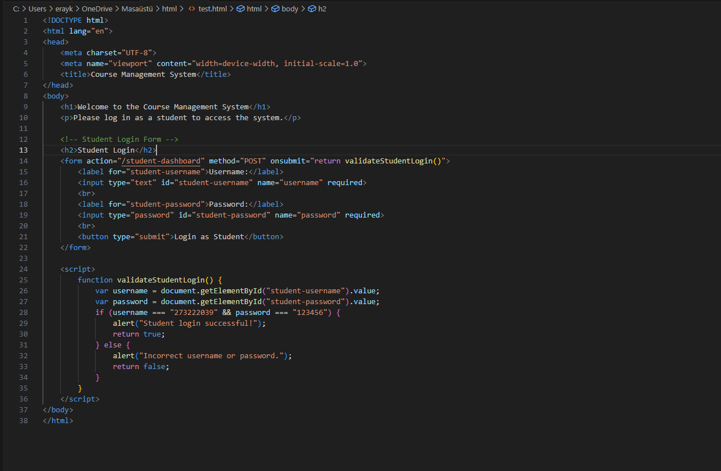

If an incorrect password is entered, the message "Invalid Faculty Number or password" will appear, and the user will be prompted with the following warning.

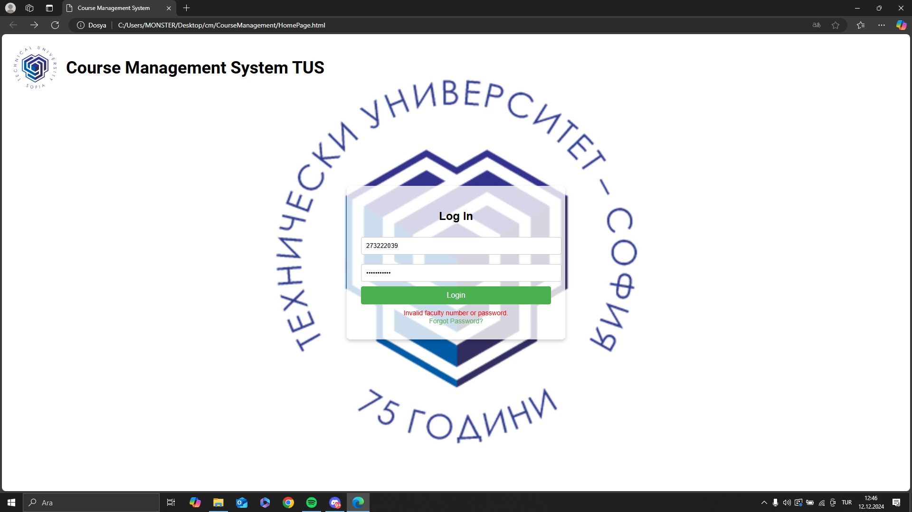

On this page, students can view the courses they wish to select along with their credits. Additionally, students can view the professors' phone numbers and office room numbers by clicking on the professors' names.

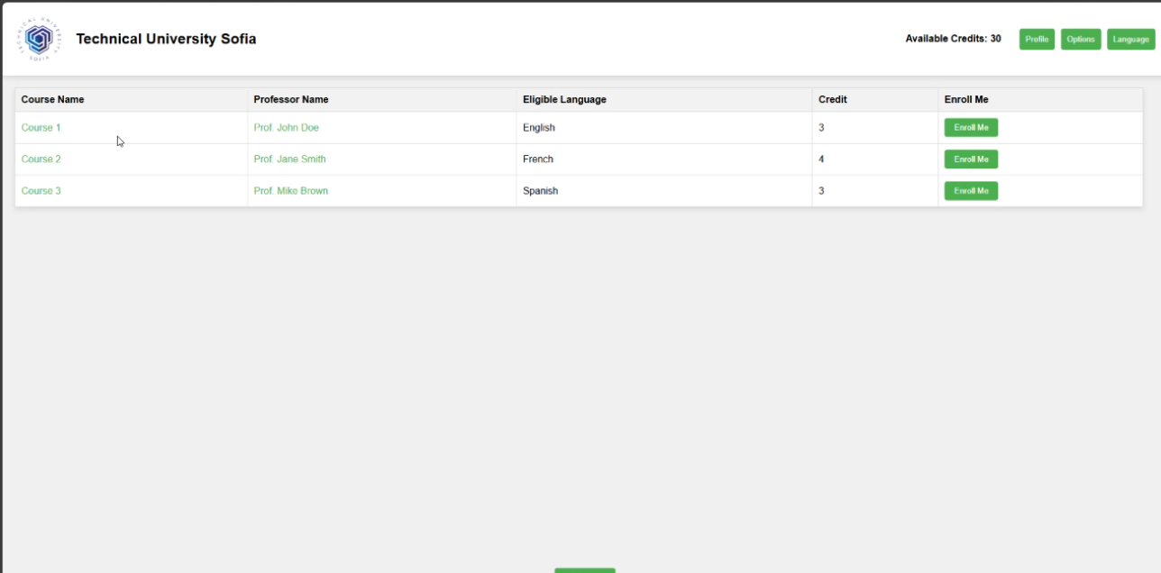

Discussions were held with the front-end developer regarding the course systems and registrations for the professors, and test cases were conducted together to ensure proper functionality.